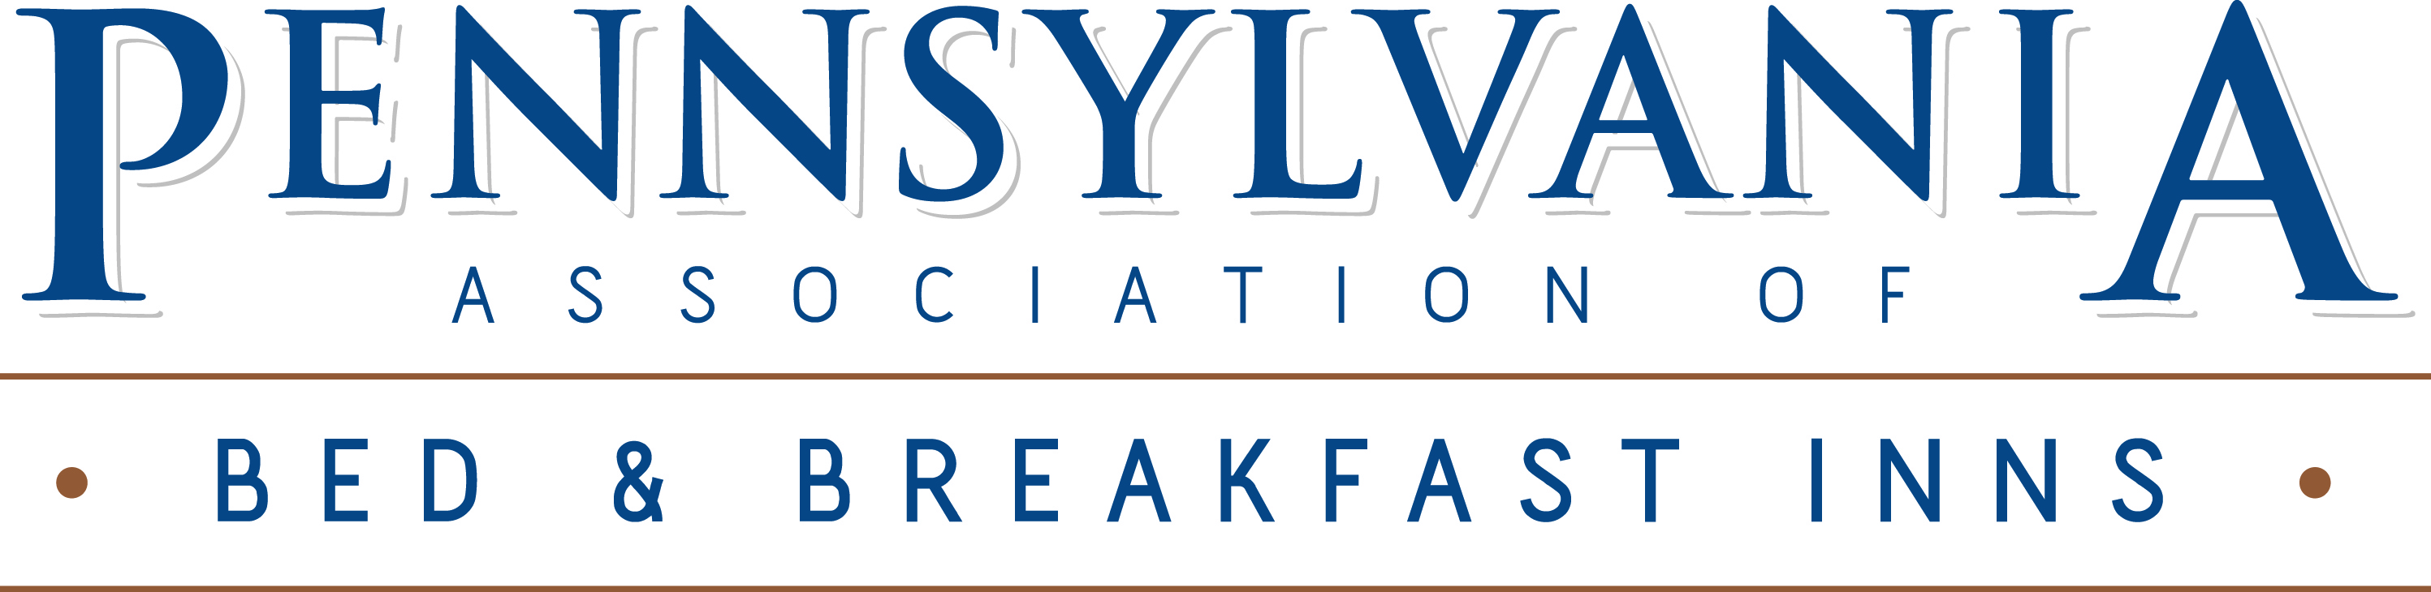

July 24, 2020

The Honorable Nancy Pelosi, Speaker The Honorable Mitch McConnell, Majority Leader
United States House of Representatives United States Senate
1236 Longworth House Office Building 317 Russell Senate Office Building
Washington, D.C. 20515 Washington, D.C. 20510

The Honorable Kevin McCarthy, Minority Leader The Honorable Charles Schumer, Minority Leader
United States House of Representatives United States Senate
2468 Rayburn House Office Building 322 Hart Senate Office Building
Washington, D.C. 20515 Washington, D.C. 20510

RE: Bed & Breakfast Industry Priorities for COVID 4

Dear Speaker Pelosi, Leader McConnell, Leader McCarthy, and Leader Schumer:

The hotel industry has been decimated by the COVID-19 health crisis. According to the Bureau of Labor Statistics (BLS), the leisure and hospitality sector has lost 4.8 million jobs since February. That is more jobs than construction, manufacturing, retail, education, and health services combined.

The bed and breakfast industry faces an unparalleled and existential crisis. The necessary actions taken by state and local governments issuing stay-at-home orders had forced our innkeepers to close or significantly limit their operations at the beginning of the pandemic. Currently, with the spike in COVID-19 cases around the country, travel is very slow to come back. Travelers are concerned for their safety or are required to quarantine if visiting certain areas.

In Pennsylvania a significant number of our bed and breakfasts could be classified as “Micro-Businesses” defined as small “Mom & Pop” businesses, which typically make less than $1.5M per year, have no full-time employees and usually only employ seasonally part-time employees (1099 contractors). These micro-businesses are being hit the hardest by the pandemic due to their minimal operating margins.

Small businesses, and especially micro-businesses are the economic backbone of our local communities. Cash flow is key for bed and breakfasts and many will have to close their doors or file bankruptcy if economic relief is not made available to these small businesses.

The Commonwealth of Pennsylvania has the second largest number (600+) of Bed and Breakfasts in the country, and has conservatively hosted 8.2 million visitors generating $1.2 billion in revenue. Our industry also serves as a significant community and economic booster by generating thousands of overnight stays creating $73.8 million in sales tax, and $36.9 million in occupancy taxes (based on 3%).

July 24, 2020
Page 2

The Pennsylvania Bed & Breakfast Association (PABBI) supports the efforts of the American Hotel & Lodging Association (AHLA). Recently AHLA submitted a letter dated July 20, 2020 regarding Hotel Industry Priorities for COVID 4 and PABBI agrees that funding for the hospitality industry needs to be a top priority of the COVID 4 package.

The ramifications of the COVID-19 pandemic National Disaster will be felt within the micro-business travel community for much longer than 12 months. For the current year, second quarter (2Q) and third quarter (3Q) revenue will be all but non-existent. That lost revenue will continue to be felt into the fourth quarter (4Q) of the current year and well into 2021 (1Q, 2Q and potentially 3Q). As an example, seasonal small businesses typically use their peak season profits to prepare for their slow season (profits go to future mortgage payments, saving for capital improvements, etc.). That is not going to happen in 2020 and many micro-businesses will feel the negative impact of the next 6-12 months for well into 2021 and beyond. The travel and tourism industry post 911 and post financial crisis in 2008, was slow to come back. It took the lodging industry 2-3 years to get back to pre-crisis occupancy levels and the COVID-19 pandemic is worse.

The current Small Business Administration (SBA) disaster relief legislation and programs appear to be focused on the immediate short-term horizon (6-12 months), a “finger in the dike” of the potential collapse of the travel industry micro-business community. Filing for Federal and State disaster relief loans is a viable option at this point; however, obtaining a loan is actually hurting these micro-businesses in the long term. By obtaining a loan, the struggling business is actually increasing their debt. Filing for and receiving a disaster relief loan is just digging a deeper hole of debt … the opposite of what innkeepers need at this point. More debt won’t help.

Universities that host major sporting events hold local economies on its shoulders. For example, what happens if Penn State University cancels the 2020 football season? For six to eight weekends each fall, Penn State home football games transforms the State College area from a string of quiet, rural communities into a bustling hub of economic activity that attracts hordes of visitors staying at our bed and breakfasts, not to mention the boost to the local bars and restaurants. Disease experts are skeptical that a 2020 football season could open on time – if at all. The stakes for businesses around State College, residents and the future of the school are sky-high. Those fall football weekends are there peak season where monies are generated to get through the low season. Without a 2020 football season, these businesses will not be able to survive without some type of government bailout legislation. This is not just unique to Pennsylvania, look across the country at smaller towns with powerhouse football programs – Starkville, Mississippi and Clemson, South Carolina – that have a rare dependence on those sports teams for their livelihood. The same effect occurs in our communities that host major entertainment venues such as Sight & Sound in Lancaster, PA and Carlisle Car Show events in Carlisle, PA. These venues/events draw thousands of visitors annually that make up a significant portion of the overnight stays at our bed and breakfasts.

As you review relief efforts in your state and across the nation, we encourage you and your colleagues to consider the following actions under your executive authority or in conjunction with your legislature:

July 24, 2020
Page 3

Direct Aid to Bed & Breakfasts

Travel Industry Micro-Business Legislation. During the 2008 financial collapse, the Federal Government passed some very heavy and powerful bailout programs (TARP and TALF) for large corporations that were failing (airlines, car manufactures, and banks). While these bailout programs were not loans, per se, and a large percentage of the funds were eventually recouped, a percentage of these bailout programs were forgiven because the US economy would have failed if those companies failed. A Travel Industry micro-business legislation, akin to the 2008 large corporation bailouts, would save the backbone of our travel and hospitality industry and our local communities. It would be a huge boost over the next 2 years for failing micro-businesses within the travel industry. It would give hope to many micro-businesses that may not have hope right now.

Provide funding for state grants to small businesses. Ensure that such support is not limited to bed and breakfasts that have closed, but to any that can easily demonstrate significant hardship especially those that do not have employees. Restaurants are another sector that has suffered substantial loses.

Assist with business interruption insurance. Actions by state and local governments to protect public health have forced bed and breakfasts to close their doors or significantly curtail their operations, resulting in major business interruption losses. Operators have paid their insurance companies for business interruption insurance for use in these circumstances. However, bed and breakfasts in Pennsylvania are seeing their claims denied by insurers due to clauses in the contract exempting viruses or pandemics from claims. The federal government needs to take action by providing a backstop for insurance companies to pay out business interruption losses either fully or a certain percentage of the losses for at least a 12-month period.

We are at a very tragic and historic point in our Nation’s history and micro-business owners need hope. These actions will not eliminate the impact of the crisis, but they will be important first steps on the road to recovery. Bed and breakfasts need to be positioned to spring back into action quickly once the crisis abates to serve our travelers and communities. Thank you for your consideration, and we stand ready to assist as you need.

Sincerely,

Carl Kosko
Chair, PABBI Board of Directors
Owner, Harvest Moon Bed & Breakfast, New Holland, PA

cc: American Hotel & Lodging Association

